Graph Calculator Manual

Contents

1) Introductions 1

2) Tools Properties 1

3) Draw a Simple Function 3

4) Draw an Implicit Function 4

5) Draw a Constant Function 5

6) Add Multiple Functions 6

7) Draw Inequality 7

8) Clear Figure 8

9) More Configuration 8

10) Several Notes 12

# Introductions

Hi! In this manual, I’m going to show you how to draw a graph using Graph Calculator (GC). Since this is still under development, I will always try to update this manual if there are any new changes. So, let’s get started!

# Tools Properties

Before I tell you how to draw a function, I will show you around the GC’s properties. After you open Graph Calculator.exe, this window will appear.

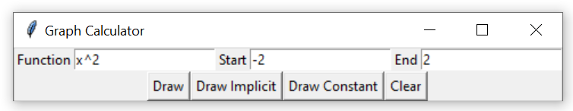

Let’s discuss it one by one.

|  |  |  |
| --- | --- | --- |
| Icon | Name | Functions |
|  | Function Box | Accepting your function. |
|  | Start Range | $x$ range starting point. |
|  | End Range | $x$ range ending point. |
|  | Draw Button | Draw a simple function. |
|  | Draw Implicit Button | Draw an implicit function. |
|  | Draw Constant Button | Draw a constant function. |
|  | Clear Button | Clear all your draw. |

After you press the Draw/Draw Implicit/Draw Constant button, a new window will appear.

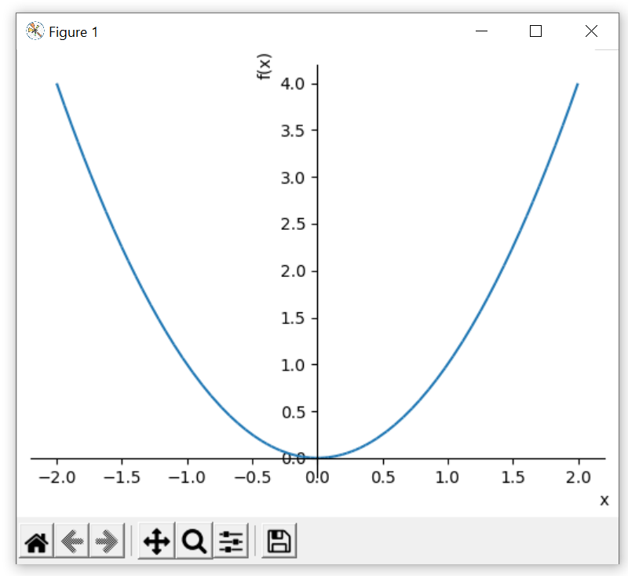

|  |  |  |
| --- | --- | --- |
| Icon | Name | Functions |
|  | Reset Button | Reset the view to the original view. |
|  | Backward Button | Back to previous view. |
|  | Forward Button | Forward to next view. |
|  | Move Button | Move the view, zoom $x/y$ fixed axes. |
|  | Zoom Button | Zoom to rectangle. |
|  | Configuration Button | Configure the plot. |
| **7** | Save Button | Save the figure. |

# Draw a Simple Function

Now I will show you how to draw a simple function. What I mean with “simple function” is a one variable function. For example: $x^{2}, x+2,\sin{x}$, etc. You can draw polynomial functions (linear, quadratic, cubic, etc.), trigonometry functions (sin, cos, tan, sec, csc, cot), exponents and logarithm functions, radical functions (only square root is available), and rational function (still under development, but you can still use it if you specify the range). Well, let’s get started.

1. Input the function you want to draw in **Function Box**.



1. Input the $x$ range you want the graph to show. Put the starting range in **Start Range**, and the ending range in **End Range**. Note: It’s okay if you leave it empty because the default range will be $-10$ to $10$.



1. After you’ve done inputting the function and the range, click **Draw Button**.



1. Voila! Your graph appears in the new window called “Figure 1”.



# Draw an Implicit Function

“What if I want to draw a circle, or a function that I can’t express explicitly?”. Don’t worry, you can draw an implicit function. The steps are still the same as when you draw a simple function, only a little bit different. Just a little bit, don’t worry!

1. Input the function you want to draw in **Function Box**. But, here’s the difference. You must write the equation ***only one of the sides***. For example: if you want to draw a circle $x^{2}+y^{2}=4$, then you must change it first to be equal to zero like this $x^{2}+y^{2}-4=0.$ After that, you will only write the left side ($x^{2}+y^{2}-4$) in the **Function Box**. Look the figure below!

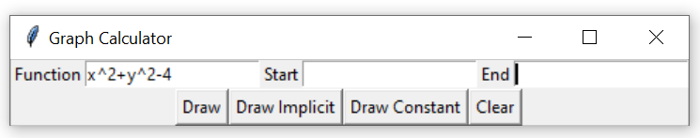

1. Input the $x$ range you want the graph to show. Put the starting range in **Start Range**, and the ending range in **End Range**. Note: It’s okay if you leave it empty because the default range will be $-10$ to $10$. Another note: You can still enter the $x$ range when you draw a circle.



1. After you’ve done input the function and the range, click **Draw Implicit Button**.



1. Voila! Your graph appears in the new window called “Figure 1”.

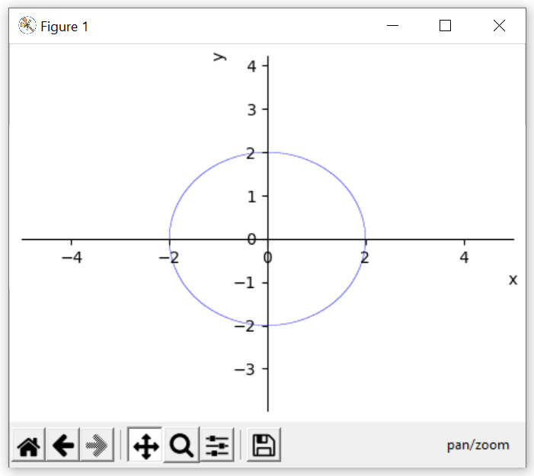

At first, you will see it as an oval. But don’t worry, it’s just a scaling problem. I will show you how to scale it later.

# Draw a Constant Function

“What if I want to draw a constant function? Can I just use the Draw Button?”. Unfortunately...no. Well, you can draw $y=c$, for a real number $c$, using the Draw Button. But you cannot draw $x=c$ with it.

“How about using the Draw Implicit Button?”. Well, you won’t like the result. Trust me! That’s why you need Draw Constant Button to draw the constant function. Of course, I hope we will only need one powerful Draw Button to draw everything, but for now, let’s just accept it how it is.

So back to the question, how to draw a constant function? Actually, the concept is the same as you draw implicit function. But let me show it again.

1. Input the function you want to draw in **Function Box**. But, here’s the difference. You must write the equation ***only one of the sides***. For example: if you want to draw a line $x=2$, then you must change it first to be equal to zero like this $x-2=0$. Then you will only write the left side ($x-2$) in the **Function Box**. Look the figure below!

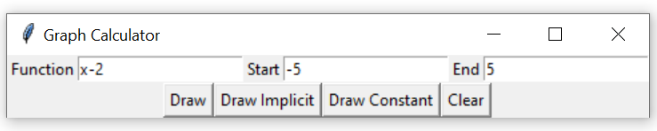

1. Input the $x$ range you want the graph to show. Put the starting range in **Start Range**, and the ending range in **End Range**. Note: It’s okay if you leave it empty because the default range will be $-10$ to $10$.



1. After you’ve done input the function and the range, click **Draw Constant Button**.



1. Voila! Your graph appears in the new window called “Figure 1”.

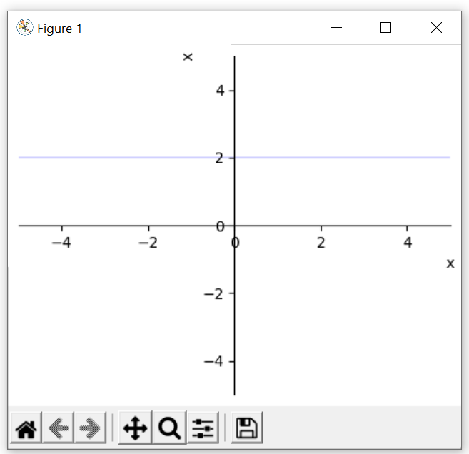

I’m sorry if the line looks so thin. I’ll try to fix it soon.

# Add Multiple Functions

Don’t worry if you want to add multiple functions in one figure. GC is powerful enough to make that happens. You just need to repeat the steps above to add a new function. You can also combine a simple function with implicit function or constant function. And you can also add as many functions as you want! (*maybe). See this figure if you don’t trust me!

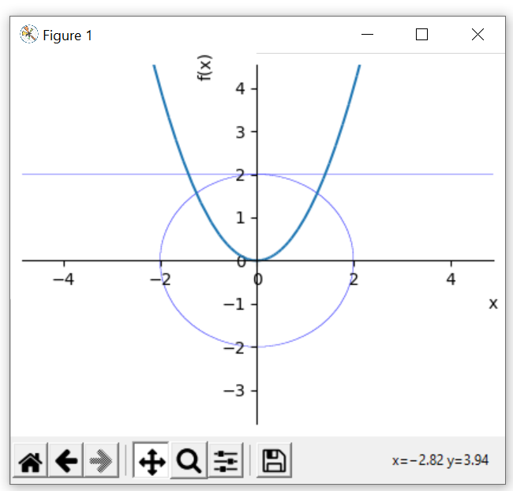

# Draw Inequality

GC can draw inequality? Of course, it can, but it’s still under development so it’s not quite useful yet. But just for your information, let me show you how to do it.

1. Input the function you want to draw in **Function Box**. But this time, you must write the ***both sides***. For example: if you want to draw $x+y<2$, then write it as it is. Look the figure below!

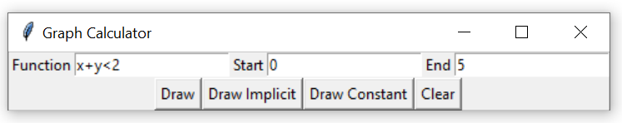

1. Input the $x$ range you want the graph to show. Put the starting range in **Start Range**, and the ending range in **End Range**. Note: It’s okay if you leave it empty because the default range will be $-10$ to $10$.



1. After you’ve done input the function and the range, click **Draw Implicit Button**.



1. Voila! Your graph appears in the new window called “Figure 1”.

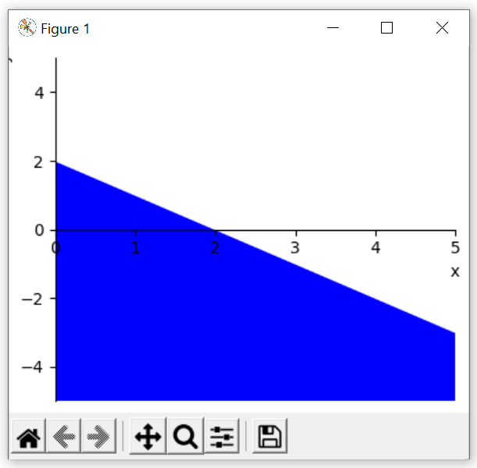

“Wow that’s cool. But why did you say that it’s not quite useful?”. Because you can only draw one inequality ☹. If you draw multiple inequalities, the result won’t be the one you’re looking for. I’ll try to fix it as soon as possible!

# Clear Figure

If you want to create a new figure, well just close the GC app and reopen it 😊. But if you’re lazy enough to do that, just press the **Clear Button**, then close the Figure.

# More Configuration

Maybe sometimes you don’t like the view of your graph. You can move the view or zoom a specific area. You can also save your figure! I will show you how to do that.

1. If you want to change the view of you graph, you can press the **Move Button**. Then left click and drag the figure anywhere you want. You will understand more if you also try it.



1. If you want to zoom the area you want or rescale the figure, there are two methods to do so. You can choose either of those.

* First method is by pressing the **Move Button**, then right click and drag the figure.



* Second method is by pressing the **Zoom Button**. Then, you must create a rectangle shape to zoom the area inside the rectangle. Just right click and drag to create the rectangle.
* 

1. If you want to reset the view to its original view, just press the **Reset Button**.



1. If you want to go back to last previous view/last next view, just press **Backward/Forward Button**.



1. More configuration can be found in **Configure Button**. Try to explore it yourself!



1. If you want to save your figure, just press the **Save Button**.



Don’t be confused with the file extension names! Here are three common file extensions used to save an image:

* Portable Network Graphics (PNG).
* Joint Photographic Expert Group (JPEG).
* Portable Document Format (PDF).

# Several Notes

Since this app is still under development and is still far from perfect, there are several things you must consider. I’ve mentioned it before in above, but I will tell it again.

Don’t worry with the black window that appear every time you open GC. That’s just a “python effect”. It will show the error if make a mistake. If you’re familiar with python, then you will understand the error.

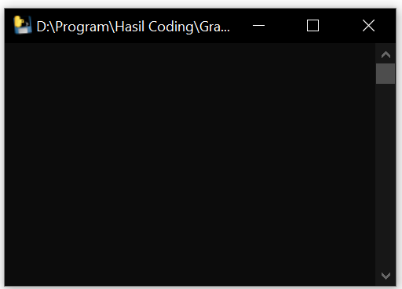

If your function has multiplication, please use the star sign (*). For example: if you want to draw $2x^{2}-3x+4$, then write it as 2*x^2-3*x+4. I know it’s a little bit rough but please hold it just a little bit longer.

Don’t worry if you leave the **Start Range** and **End Range** empty because it will use the default range, that is $-10$ to $10$. But, don’t just leave one of them empty because it will keep using the default range.